Repositories/ice2021/crystals/2024-06-27/case2.8/

This a version of GNBF_4_flattenandfilter uses plotly to image a prismatic surface. There is a lot of variation in the y-direction. This looks like an ablation scenario.

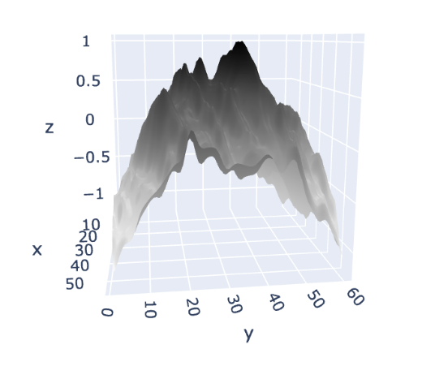

Repositories/ice2021/crystals/2023-07-18/30Pa/case1.0 (calibration)/

Segments2_2

|  |  |
| --- | --- |
|  |  |
|  |

Repositories/ice2021/crystals/2023-07-18/30Pa/case1.0 (calibration)/

Segments1

|  |  |
| --- | --- |
|  |  |
|  |
|  |
|  |